RAISA

Observations and Playtester Comments

# In-Game Observations

[Your thoughts as you watch the testers play]

* Most things are not done yet
* Need to have more interactivity
* Really just walking around and looking for people

# In-Game Questions

Why did you make that choice?

* Wanted to talk to people

What did you think that would do?

* Be able to talk to people

What is confusing for you?

* Some people are mute

# Postgame Questions

[Questions you ask the testers as they have played]

* Did you like the bunny? Yes
* Did going into the houses make sense? Yes
* Did you feel like there were too many characters? no

## General Questions

What was your ﬁrst impression?

* Cool graphics, nice sound

How did that impression change as you played?

* Was disappointed she couldn’t talk to more people

Was there anything you found frustrating?

* Some people were mute

Did the game drag at any point?

* Not much of a story right now

Were there particular aspects that you found satisfying?

* The cartoons

What was the most exciting moment in the game?

* When someone talked to her

Did the game feel too long, too short, or just about right?

* NA

## Formal Elements

Describe the objective of the game.

* NA because no backstory yet still

Was the objective clear at all times?

* NA

What types of choices did you make during the game?

* Getting into places where I know I can find people, who to talk to

What was the most important decision you made?

* To go into a house to talk

What was your strategy for winning?

* NA

Did you ﬁnd any loopholes in the system?

* Some people cannot talk

How would you describe the conﬂict?

* NA

In what way did you interact with other players?

* NA

Do you prefer to play alone or with human opponents?

* alone

What elements do you think could be improved?

* More people talking and a clear storyline

## Dramatic Elements

Was the game’s premise appealing to you?

* yes

Did the story enhance or detract from the game?

* Enhance while it could

As you played, did the story evolve with the game?

* NA

Is this game appropriate for the target audience?

* yes

On a piece of paper, graph your emotional involvement over the course of the game.

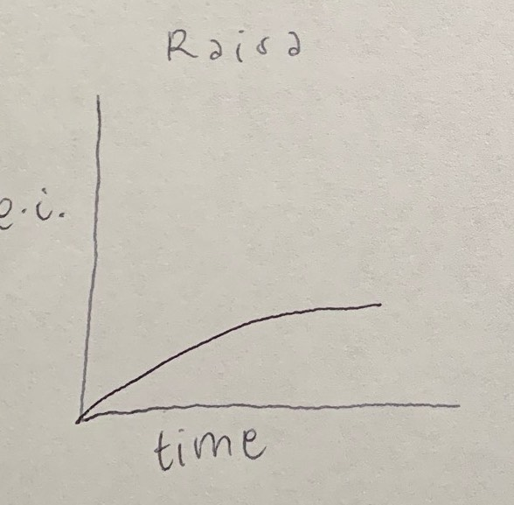

Did you feel a sense of dramatic climax as the game progressed?

* No

How would you make the story and game work better as a whole?

* Add more storyline

## Procedures, rules, interface, and controls

Were the procedures and rules easy to understand?

* Yes, just moving around and talking to people

How did the controls feel? Did they make sense?

* Yes, just use arrow keys and space

Could you ﬁnd the information you needed on the interface?

* No, need to tell about the keys to move

Was there anything about the interface you would change?

* Tell the keys in the beginning

Did anything feel clunky, awkward, or confusing?

* no

Are there any controls or interface features you would like to see added?

* keys

## End of Session

Overall, how would you describe this game’s appeal?

* If it was finished, could see children playing the game

Would you purchase this game?

* no

What was missing from the game?

* A storyline and interactivity

If you could change just one thing, what would it be?

* More people talking

Who do you think is the target audience for this game?

* children

If you were to give this game as a gift, who would you give it to?

* My niece or nephew

# Revision Ideas

[Ideas you have for improving the game]

* Add arrow keys in beginning screens
* Add box colliders to make people more interactable